Dyne, Melanie (from Linked In)

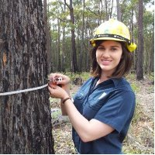
Bachelor of Science (Forestry) ANU 2009 ?, Bachelor of Arts (Classics Major) ANU 2006 ?

Student Forester Forests NSW 2006 –2007 Bombala. Seasonal Firefighter Parks, Conservation & Lands 2008 –2008 ACT. Student Forester Forests NSW 2008 –2009 Bathurst. Tactical Planning Forester & OHS Representative VicForests 2009 –2011 Cann River, Vic. Harvest Planning Forester Forests NSW 2012 Eden, NSW. Forester (Ecology) Forestry Corporation of NSW 2013 Eden, NSW. Community Programs Officer Forestry Corporation of NSW 2013 – , Bathurst.
Activities and Societies: International Forestry Student's Association, International Forestry Student's Symposium (South Africa), SRES / Forestry Students Society, Institute of Foresters of Australia (IFA).

